## **Download & Install Grafana using TAR and RPM**

Standalone Linux Binaries(64 Bit)SHA256:

$ cd /opt/

$ wget https://dl.grafana.com/oss/release/grafana-8.1.5.linux-amd64.tar.gz

$ tar -zxvf grafana-8.1.5.linux-amd64.tar.gz

$ cd grafana-8.1.5

$ cd bin

$ nohup ./grafana-server &

$ ps -eaf | grep gra

Red Hat, CentOS, RHEL, and Fedora(64 Bit)SHA256:

$ wget https://dl.grafana.com/oss/release/grafana-8.0.5-1.x86_64.rpm

$ sudo yum install grafana-8.0.5-1.x86_64.rpm

## **Ubuntu and Debian**

sudo apt-get install -y adduser libfontconfig1

wget https://dl.grafana.com/oss/release/grafana_8.1.5_amd64.deb

sudo dpkg -i grafana_8.1.5_amd64.deb

## **Standalone Linux Binaries(64 Bit)**

wget https://dl.grafana.com/oss/release/grafana-8.1.5.linux-amd64.tar.gz

tar -zxvf grafana-8.1.5.linux-amd64.tar.gz

## **Red Hat, CentOS, RHEL, and Fedora(64 Bit)**

wget https://dl.grafana.com/oss/release/grafana-8.1.5-1.x86_64.rpm

sudo yum install grafana-8.1.5-1.x86_64.rpm

## **OpenSUSE and SUSE**

wget https://dl.grafana.com/oss/release/grafana-8.1.5-1.x86_64.rpm

sudo rpm -i --nodeps grafana-8.1.5-1.x86_64.rpm

## **Download & Install Grafana using YUM Repo (Optional)**

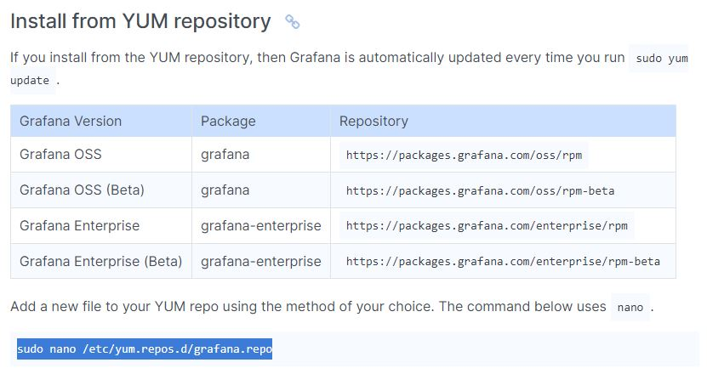

Grafana Version Package Repository

Grafana OSS grafana https://packages.grafana.com/oss/rpm

Grafana OSS (Beta) grafana https://packages.grafana.com/oss/rpm-beta

Grafana Enterprise grafana-enterprise https://packages.grafana.com/enterprise/rpm

Grafana Enterprise (Beta) grafana-enterprise https://packages.grafana.com/enterprise/rpm-beta

Add a new file to your YUM repo using the method of your choice. The command below uses nano.

sudo nano /etc/yum.repos.d/grafana.repo

For Enterprise releases:

[grafana]

name=grafana

baseurl=https://packages.grafana.com/enterprise/rpm

repo_gpgcheck=1

enabled=1

gpgcheck=1

gpgkey=https://packages.grafana.com/gpg.key

sslverify=1

sslcacert=/etc/pki/tls/certs/ca-bundle.crt

For OSS releases:

[grafana]

name=grafana

baseurl=https://packages.grafana.com/oss/rpm

repo_gpgcheck=1

enabled=1

gpgcheck=1

gpgkey=https://packages.grafana.com/gpg.key

sslverify=1

sslcacert=/etc/pki/tls/certs/ca-bundle.crt

Install Grafana with one of the following commands:

$ sudo yum install grafana

# or

$ sudo yum install grafana-enterprise

## **Step 2 – Understand Grafana Installation details in RHEL/CENTOS**

Installs binary to /usr/sbin/grafana-server

Copies init.d script to /etc/init.d/grafana-server

Installs binary to /usr/sbin/grafana-server

Copies init.d script to /etc/init.d/grafana-server

Installs default file (environment vars) to /etc/sysconfig/grafana-server

Copies configuration file to /etc/grafana/grafana.ini

Installs systemd service (if systemd is available) name grafana-server.service

The default configuration uses a log file at /var/log/grafana/grafana.log

The default configuration specifies an sqlite3 database at /var/lib/grafana/grafana.db

## **Step 3 – Start the server (init.d service)**

# Start the server with systemd - To start the service and verify that the service has started:

$ sudo systemctl daemon-reload

$ sudo systemctl start grafana-server

$ sudo systemctl status grafana-server

# Configure the Grafana server to start at boot:

$ sudo systemctl enable grafana-server

# Start the server with init.d - To start the service and verify that the service has started:

$ sudo service grafana-server start

$ sudo service grafana-server status

# Configure the Grafana server to start at boot:

$ sudo /sbin/chkconfig --add grafana-server

This will start the grafana-server process as the grafana user, which is created during package installation. The default HTTP port is 3000, and default user and group is admin.

## **Step 4 – Configure the Grafana server to start at boot time**

$ sudo /sbin/chkconfig --add grafana-server

$ sudo systemctl enable grafana-server.service

$ systemctl daemon-reload

$ systemctl start grafana-server

$ systemctl status grafana-server

## **Step 5 – Grafana server Environment file**

The systemd service file and init.d script both use the file located at /etc/sysconfig/grafana-server for environment variables used when starting the back-end. Here you can override log directory, data directory and other variables.

## **Step 6 – Grafana server Log**

By default Grafana will log to */var/log/grafana*

## **Step 7 – Grafana Database**

The default configuration specifies a sqlite3 database located at /var/lib/grafana/grafana.db. Please backup this database before upgrades.

You can also use MySQL or Postgres as the Grafana database, as detailed on

http://docs.grafana.org/installation/configuration/#database

## **Step 8 – Grafana configuration**

The configuration file is located at /etc/grafana/grafana.ini. Go the Configuration page for details on all those options. You can add following data sources

1. Graphite
2. InfluxDB
3. OpenTSDB
4. Prometheus

## **Step 9 – Server side image rendering**

Server side image (png) rendering is a feature that is optional but very useful when sharing visualizations, for example in alert notifications.

$ sudo yum install fontconfig -y

$ sudo yum install freetype* -y

$ sudo yum install urw-fonts -y

## **Step 10 – Browse the dashboard**

http://X.X.X.X.:3000/

Username - admin

Password - admin